**Information Systems Management: Wednesdays @ 11:00**

Facebook> Promote> Community> People/Client/Stakeholders/Users e.g. ICT(Information Computer Technologies skills) > Computer Skilled Technical Users (IT).

CA 10% Designing a Poster: Due week 8, after reading week. (4th Nov)

CA 20% Report on Security Analysis for a company: Due week 12. Week before we finish up. (3rd Dec)

Last Week (Week 13: 10th Dec-17th) = Exam Prep 70%.

* Same format as previous years for exam
* Will be given samples, tips and chapters to focus on

Contact details for Catherine Mulwa:

1. [Catherine.Mulwa@staff.ncirl.ie](mailto:Catherine.Mulwa@staff.ncirl.ie)
2. [CatherineMulwa@Yahoo.com](mailto:CatherineMulwa@Yahoo.com) (Skype)
3. [CatherineMulway@gmail.com](mailto:CatherineMulway@gmail.com)

Information Systems Class Notes:

Types of Information Systems: Google & Baidu(the google for China)

Main type = Data

Data

1. Access 2. Globally

People >>> Client Tier > Business Logic Tier > Data Persistence Tier.

Three Tier Architectural Design:

E.g. Facebook as a company.

|  |
| --- |
| User Interface  Tier 1: Client Tier. |
|  |
|  |

**Lecture week 5.**

**Intangible** asset is an asset that lacks physical substance and is usually very hard to evaluate. According to our text book examples are knowledge, brands, reputations, and unique business processes.

Others include patents, copyright, franchises, trade names, and general interpretations. Extra examples include software and other intangible computer-based assets.

**Tangible –** capable of being touched. (perceptible) it’s real, or actual. In addition, it’s not imaginary.

**Knowledge Management Cycle**

* Find- (capture, identify, analyse existing knowledge)
* Share-linked to organising
* Organise- linked to sharing -1. Taxonomy (break down structure) including methods, surveys, interviews as two elements of wbs, then break them down. 2.Metadata, 3. Structure.
* Use or re use of knowledge – linked to find ( promote, rewards, encourage)

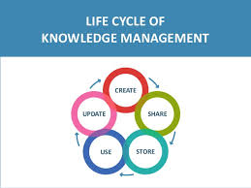 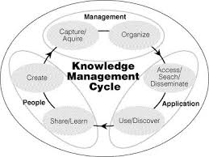

**Important dimensions of Knowledge:**

* Knowledge has a location.
  + Cognitive events: involves the mental models and maps of individuals.
  + Both social and individual.
* Knowledge is situational.
  + Conditional:
  + Contextual:

**Organizational Learning: Process in which organizations learn.**

* Process in which organizations learn:
  + Gain experience through collection of data

**Definition of Knowledge Management:** Set of business processes developed in an organisation to create, store, and transfer, and apply knowledge.

**Knowledge Management value Chain:**

* Each stage adds value to raw data and information as they are transformed into usable data.

1. Knowledge acquisition:
   * Documenting tacit and explicit knowledge:
     + Storing documents, reports, presentations, best practices.
     + Unstructured documents e.g. emails.
     + Developing online expert networks.
2. Knowledge storage:
   * Databases
   * Document management systems e.g. Moodle
   * Role of management:
     + Support development of planned knowledge storage systems.
     + Indexing, schemas
     + Reward employees for taking time to update and store documents properly.
3. Knowledge dissemination
   * Portals, wikis e.g. Google Docs.
   * Email, instant messaging
   * Search engines
   * Collaboration tools
   * A deluge of information?
     + Training programs, informal networks, and shared management experience help managers focus attention on important information.
4. Knowledge application
   * To provide return on investment (ROI), organisational knowledge must become systematic part of management decision making and become situated

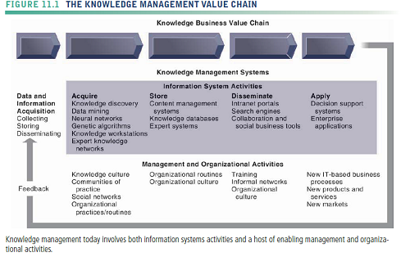

**Three Major types of knowledge management systems.**

Q. Describe the three major types of the Knowledge management systems.

1. Enterprise-wide knowledge management systems

* General-purpose firm-wide efforts to collect, store, distribute, and apply digital content and knowledge

1. Knowledge work Systems (kws)

* Specialized systems build for engineers, scientists, other knowledge workers charged with discovery and creating new knowledge.

1. Intelligent techniques

* Diverse group of techniques such as data mining used for various goals: discovering knowledge, distilling knowledge, discovering optimal solutions.

Q. Compare and contrast the three major types of knowledge management systems.

(make sure you compare them against each other to gain full marks. A way to help doing this would be creating three columns and having points of each time comparing to other)

**Enterprise content management systems:**

* They help to capture, store, retrieve, distribute, preserve
  + Documents, reports, best practices
  + Semi-structured knowledge
* Bring in external sources
  + News feeds, research e.g. RSS Feeds on Google
* Tools for communication and collaboration
  + Blogs, wikis etc.,

If I can’t remember how to explain, then I can draw the diagram and give a little explanation for ¾ of the marks.

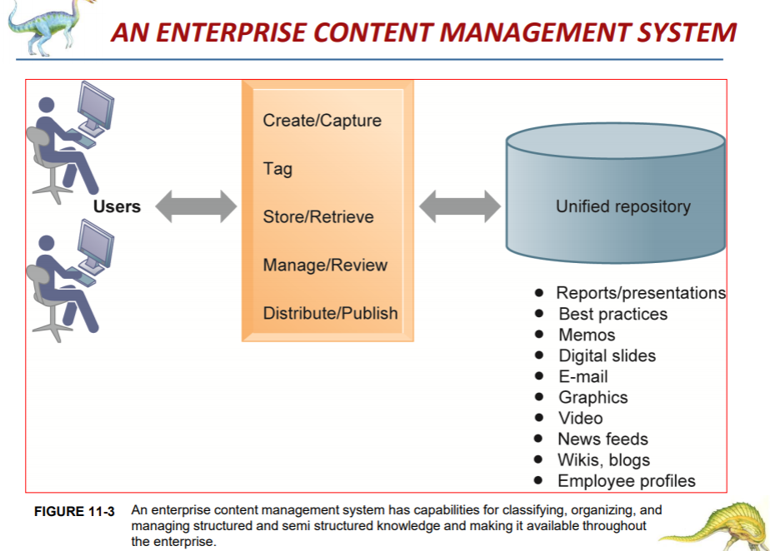

**Collaboration and social tools**

* Social bookmarking
  + Sharing and tagging bookmarks e.g. (Bookmarking Moodle on my laptop)
* Folksonomies
  + User-created taxonomies for tagging
* Examples:
  + Delicious
  + Slashdot
  + Pinterest

Chapter 14: The importance of Project Management. (Not on test)

Notes:

Runaway projects- Projects end up out of control

No scope

No clear defined objectives

To start or end dates

Runaway projects share one thing in common… the root to failure

System failures- fail to capture essential business requirements

It’s important to incorporate business requirements to avoid delivering unwanted results.

Each business has different business requirements depending on the nature of the business. E.G. Facebook - Login/ Authentication.

Project Management key terms:

Project Gantt Charts – Tasks

Predecessors

Resources – clear identified allocation

What % to whom

Milestone for project – when are the deliverables

Five major variables for project management:

1. Scope
2. Time
3. Cost
4. Quality
5. Risk

Amazon, eBay – great example of an information system that you need very little guidance to use.

Project Gantt Chart should include the following:

1. Task Numbers
2. Task Names
3. Task Description (Brief)
4. Task Duration (Present in Months format if long project) Don’t Include Sat and Sun.
   1. Start of Task
   2. End of Task
5. Resources
   1. Recommended to provide resources within % of man power.
   2. Amount of effort is important to note. If Human resources involved what amount effort should be given from each resource.
6. Predecessors – Which task/activity is priority over other tasks/ activity. Which activity is dependent on another activity?
7. Milestones – Don’t have times set for them. Should be 0. It’s the tasks to achieve that milestone that has time allocated.

Proposals for projects must incorporate any risks of the project... big or small risks. E.g. being sick. Being away. Not capable for completing a task.

Critical paths should be set to determine time management. And include it in reports

Exam Revision:

2017/2018 past papers focus on as similar style questions

Jan 7th 10:00-12:00. 2hours, answer 3 questions.

Main Topics:

**Chapter 1: Question worth 100 marks on this chapter. Part A and B question structure. A=60 Marks B=40 Marks**

- Focus on trying to understand the role of information systems in business today. What role they play.

- Understand the significance of Information Systems, regard to businesses. Why are they important/crucial?

- What are the strategic Business Objectives?

-Try to understand the different types of business process management activities.

**Chapter 2: Chapter 1 and question 2 are merged into one question.**

- Focus more on the business processes. Sample question was done in class

**Chapter 3:**

-Key Concepts/terms:

1. Michael Porters Model – Competitive

2. Business Ecosystem Strategic Model

Solution done in class

**Chapter 8:**

- System vulnerability and Abuse

- Technologies and tools for Protecting Information Resources

**Chapter 10:**

- Types of Ecommerce. slide 19 on week 11 notes. Mobile commerce and B2B B2C. Emphasis on these. Solution in class done on this question.

**Chapter 13:**

Building Information Systems CHAPTER:

Business Process Management Activities. Try to understand the activities of BPM.

Outsourcing: Significance of outsourcing. It’s the outsourcing of the Information Technology services and the types of hidden costs they have. Costs that might not be obvious, and you may be unaware of.

Tips and tricks:

Provide examples in each answer given.

3 diff styles of questions:

1. Compare and Contrast (e.g. compare and contrast two for the business models. Explain what each are. Describe then the differences of the two and ten the similarities. Explain B2C, EXPLAIN B2B AND THEN COMPARE THEM.
2. Discuss: Discuss the ecosystem model: Don’t just say what it is. Discuss he different components that make the ecosystem model, the benefits of it and how the model is used. Why is the ecosystem being important? Include examples. Where you have the models, draw them. Then elaborate.
3. Explain: Explain your understanding of the question being asked. Is it understanding the roles of information systems today? Why they’re important. Explain IS have this significance, they do this, and companies benefit of these because of this…

Know the differences of these.

Draw ecosystem and the Michael force model.

Answer each question in exam on a new page.